**In R-Studio,**

**Run different arithmetic operators.**

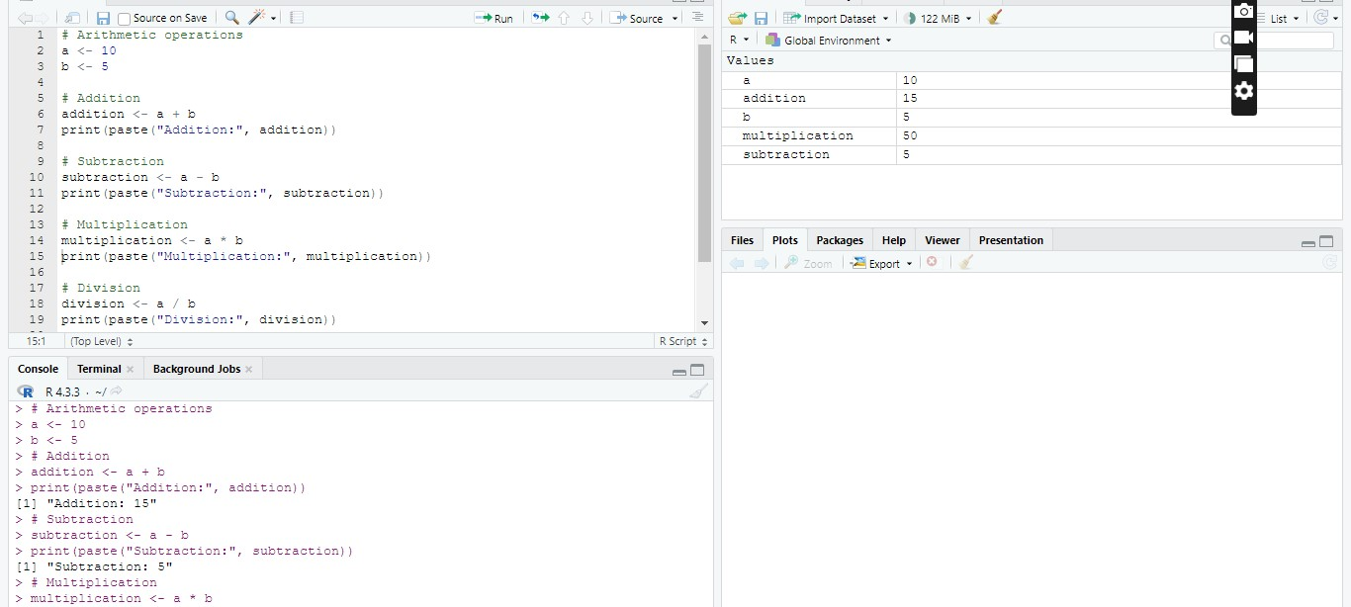

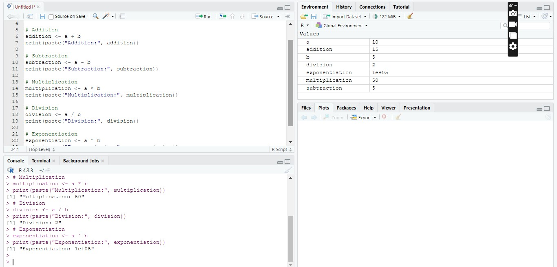

**Create two vectors; one containing numeric and another on characters**

**data type.**

